MONTHLY TEST JULY-2020
SUBJECT: ACCOUNTANCY

STD: XI B MARKS: 25
DATE:3 /07/2020 TIME: 1Hrs
Find answers for the following [1x5=5]
1. A document which provides evidence of the transactions is called the -------------------
2. It is prepared at the time of sale of goods by seller which contains all the details is ------------
3. A -------------- is arder in writing, drawn upon a specified banker and payable on demand
4.it is used when a customer give cash to the business firm
a.Debit note
b. Credit note
c. Receipt
5. recording of trasactionin the books of accounts is done on the basis of ----------------
6. Three types of Accounting vouchers are [3]
a.---------------
b.-------------
c.----------------------
7. What is meant by Accounting Equation? [2]
8. Kunal started a business , he has the following transcations…… [5]
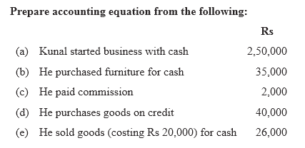
9. Naren has the following transaction. Prepare Accounting Equation. [8]

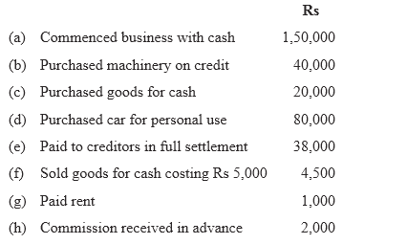
10. Give a specimen of account. [2]

